**DAILY ONLINE ACTIVITIES SUMMARY**

|  |  |  |  |  |  |  |  |  |
| --- | --- | --- | --- | --- | --- | --- | --- | --- |
| **Date:** | **03/07/2020** | | | | | **Name:** | **NAIPUNYA VINOD NAIK** | |
| **Sem & Sec** | **IV SEM & A SECTION** | | | | | **USN:** | **4AL18CS050** | |
| **Online Test Summary** | | | | | | | | |
| **Subject** | | **NO INTERNALS CONDUCTED** | | | | | | |
| **Max. Marks** | | **-----------------** | | **Score** | | | **------------------** | |
| **Certification Course Summary** | | | | | | | | |
| **Course** | **1) D PROGRAMMING HANDS ON-0 TO OBJECT ORIENTED CODING:NEXT C++**  **2) WEBINAR ON C PROGRAMMING** | | | | | | | |
| **Certificate Provider** | | | **1) UDEMY**  **2) AIET** | | **Duration** | | | **1) 5 HRS**  **2) 1.4HRS** |
| **Coding Challenges** | | | | | | | | |
| **Problem Statement: NO PROBLEM STATEMENT GIVEN TODAY** | | | | | | | | |
| **Status:-----------------------** | | | | | | | | |
| **Uploaded the report in Github** | | | | | **YES** | | | |
| **If yes Repository name** | | | | | <https://github.com/naipunya-naik/lockdown-coding> | | | |
| **Uploaded the report in slack** | | | | | **YES** | | | |

Online Test Details: (Attach the snapshot and briefly write the report for the same)

NO INTERNALS CONDUCTED

Certification Course Details: (Attach the snapshot and briefly write the report for the same).

CERTIFICATION COURSE NAME:-  **D PROGRAMMING HANDS ON-0 TO OBJECT ORIENTED CODING:NEXT C++**

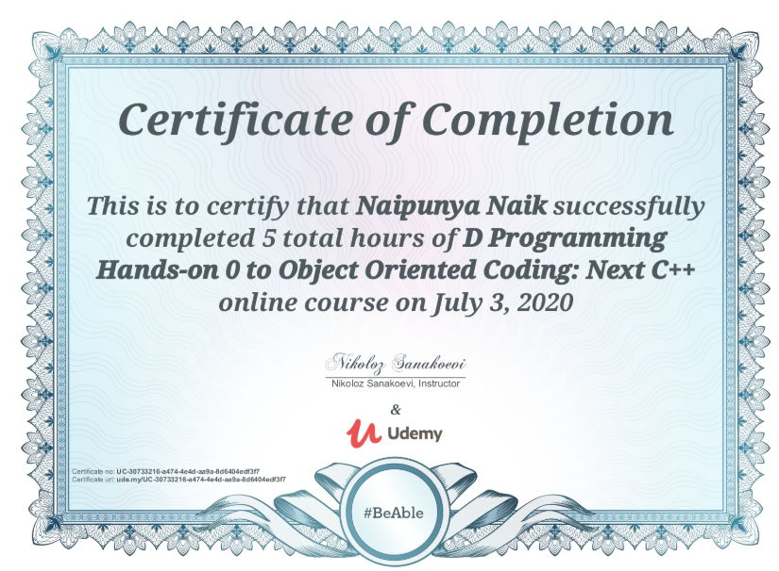

TOPICS COVERED ON 03 JULY 2020:-

* **Simple Variables**
* **IO**
* **User-defined types**
* **Logic**
* **Derived data types**
* **Loops**
* **Functions**
* **Modules**
* **Templates**
* **Object Oriented Programming**

2) WEBINAR ON C PROGRAMMING

* CONDUCTED BY:- MS.MEGHA.D.HEGDE,ASST.PROF,CSE DEPT,AIET.
* DURATION:- 1.4 HRS
* FROM 2.30PM TO 4.10 PM

TOPICS COVERED TODAY

* INDIVIDUAL SPEECH SESSION FOR 5 MIN
* CONDITIONAL LOOPING STATEMENTS
* DESCRIPTION OF ARRAYS
* IF ,IF-ELSE,SWITCH,CONTINUE,GOTO STATEMENTS
* DEMONSTRATION OF PRIME NUMBER,VOWEL PROGRAMS.
* QUIZ,QUIZ COMPRISED OF 6 QUESTIONS OF 5 MARKS EACH
* TOTAL MARKS:30
* GENERAL KNOWLEDGE QUIZ
* SNAPSHOTS OF TODAY’S WEBINAR

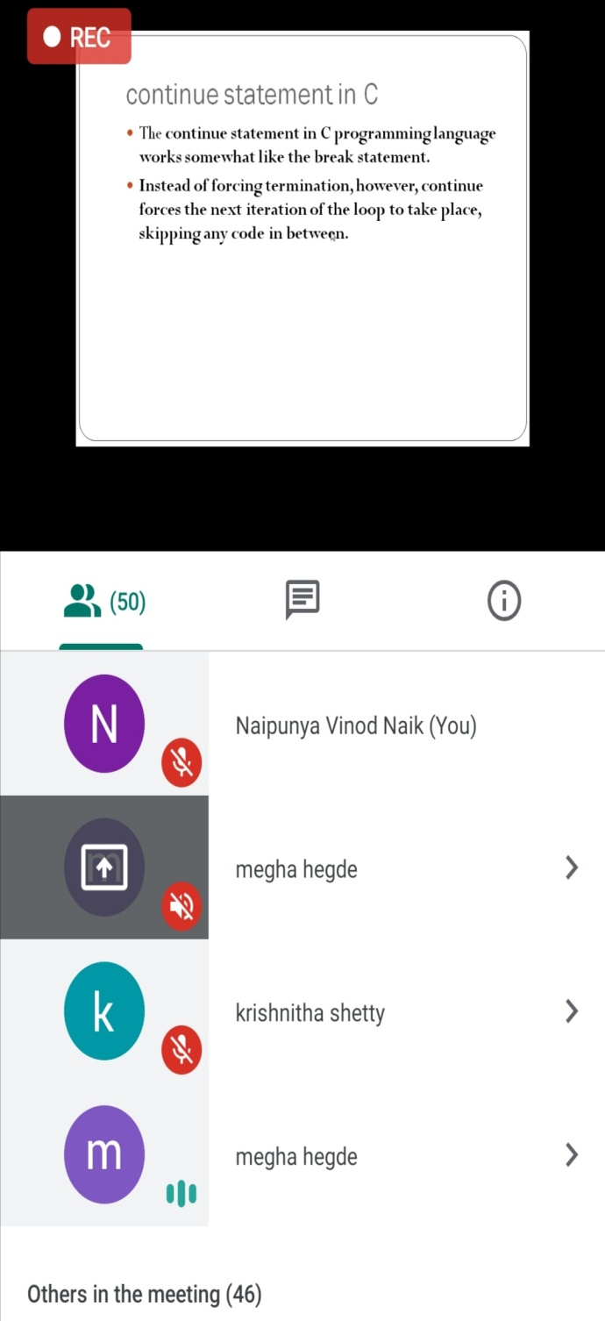 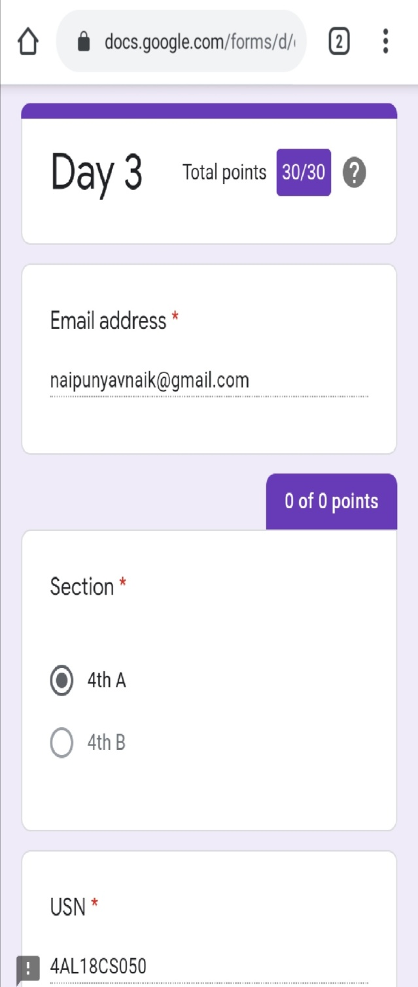

Coding Challenges Details: (Attach the snapshot and briefly write the report for the same)

NO PROBLEM STATEMENT GIVEN TODAY.